COVID contingency and outbreak plan 2021-22
When should my child self-isolate or miss school?  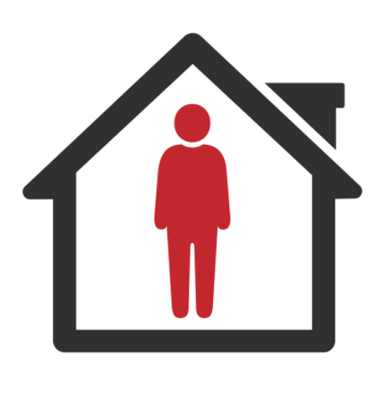 | YES | - If your child develops Covid symptoms at home, they should stay at home and should book a Lateral Flow Test (LFT) test.  - If your child develops Covid symptoms at school, they will be sent home and will be required to be symptom free and have a negative LFT to return to school.  - If your child tests positive for Covid, they will need to self-isolate. The rest of the household does not need to self-isolate if they are under 18 or fully vaccinated – but should take daily LFTs for 7 days to ensure that they are negative before leaving the house.
 | NO | - All children MUST attend school unless they are ill.  - From 16th August 2021, children under 18 (or double-vaccinated adults) do not need to self-isolate or miss school if a member of their household or a contact, has Covid.  - Instead, they will need to take daily Lateral Flow Tests for 7 days andt can continue coming to school so long as they have no symptoms and the test result is negative.

Stage 1 - ‘normal’ Circumstances: -
Community  Covid Risk | Description | Actions
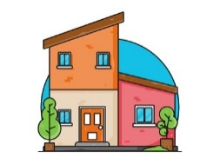  Low Community Transmission.  No School Cases | - There have been no cases of Covid within school for 10 school days.  - Cases of Covid locally are low and / or stable.  - Hospitalisation/ Deaths due to Covid nationally are low. | No Covid measures are necessary beyond:  - Reminding children of good hand-hygiene.  - Ensuring good ventilation encouraged where practical.  - Ensuring Children / Staff stay at home if they have Covid symptoms (and book a PCR test).  - Mixing of Bubbles and whole school assembly.  Staff (who have opted in) will continue to test themselves using Lateral flow tests (until the end of September) as in line with government guidance.

Stage 2.1 - A single child tests positive
Community  Covid Risk | Description | Actions
A single child tests Positive | - A single child tests positive for Covid in a class.  - No other classes or year groups are affected. | - The child self-isolates for 10 days. Remote learning will be provided if they are well enough to complete it.  - The parents of the child may be contacted directly by NHS Track and Trace to establish likely contacts.  - Close contacts will be required to take a daily Lateral Flow Test (LFT) for 7 days, before leaving their home.  - Children do not need to miss school or self-isolate unless they have symptoms of Covid or have tested positive on an LFT.

Stage 2.2 – Isolated cases within classes across the school
Community  Covid Risk | Description | Actions
A single child tests Positive | - 1 or 2 children test positive for Covid in a particular class.  - Other classes or year groups in the school may be affected. | - The child/ren self-isolate for 10 days. Remote learning will be provided if they are well enough to complete it.  - The parents of the child/ren may be contacted directly by NHS Track and Trace to establish likely contacts.  - Close contacts will be required to take a daily Lateral Flow Test (LFT) for 7 days, before leaving their home.  - Children do not need to miss school or self-isolate unless they have symptoms of Covid or have tested positive on an LFT.

Stage 3 - An outbreak within a class
Community  Covid Risk | Description | Actions
5 children or staff within a class test positive within 10 days of each other. | - There have been 5 or more cases of Covid across a class within 10 days which could mean that Covid is spreading within that group of children. | - Follow above actions above for each positive case.  - The school will discuss the outbreak with Public Health and agree strengthening protective measures for 10 school days, including:  - Any class with 5 or more cases will revert back to becoming a class bubble  - Increase hand washing routines  - Reverting to video-link Assemblies in classrooms.  - Have separate areas for break-time and lunch (away from rest of school).  - Eat in separate areas away from the rest of the school.  - Wipe down desks more frequently.  - Have some lessons outside if the weather allows.  - Reducing the amount of classes that staff work across.  - Staff social distancing and use of PPE as appropriate.  - Encouraging daily staff Lateral flow testing.  - Adapting, Limiting or Postponing indoor sporting events, trips, open days and performances.  - Enhanced cleaning of toilets during school day.

Stage 4 - Covid cases continue to rise rapidly within a 10 day period
Community  Covid Risk | Description | Actions
Covid cases continue to increase rapidly within a 10 day period. | - Despite the measures indicated above, Covid cases within the school continue to rise within a 10 day period with multiple classes and staff affected, suggesting that Covid is spreading widely throughout the school. | - The school will discuss the outbreak with Public Health and agree strengthening protective measures for 10 school days, including:  - Re-introducing class bubbles for 4-6 weeks.  - Reverting to strict measures re. staggered start and end times to the day may be reinstated for 4-6 weeks.  - Staggered break and lunchtimes may be reinstated for 4-6 weeks.  - Limiting all non-essential visitors to school.  - Face coverings for staff (and essential visitors) in communal areas.  - Postponing all non-essential events.  - After school/Extra-curricular clubs postponed.  - No Whole school gatherings i.e. for assemblies and Mass.  - Consideration given and guidance taken as to whether to re-introduce remote learning for individual classes for 10 school days.

Stage 5 - Rapidly rising COVID 19 in the community
Community  Covid Risk | Description | Actions
Rapidly Rising Community Transmission | - Cases of Covid are rising rapidly in the community causing disruption to other local schools.  - Public Health England issue warnings of expected local/ national infection wave. | - Ventilation of classrooms increased & hand-washing supervised.  - Large indoor public performance audience numbers reduced.  - Staff-room capacity is reduced.  - Staff social distancing and use of PPE as appropriate  - Whole school mixing is replaced with the reintroduction of Bubbles, Whole school assemblies are replaced with virtual assemblies  - Clinically Vulnerable staff meet with Line-Managers to review their individual risk assessment & discuss additional protection (e.g. use of face coverings, reduction in movement between classes/ groups).

